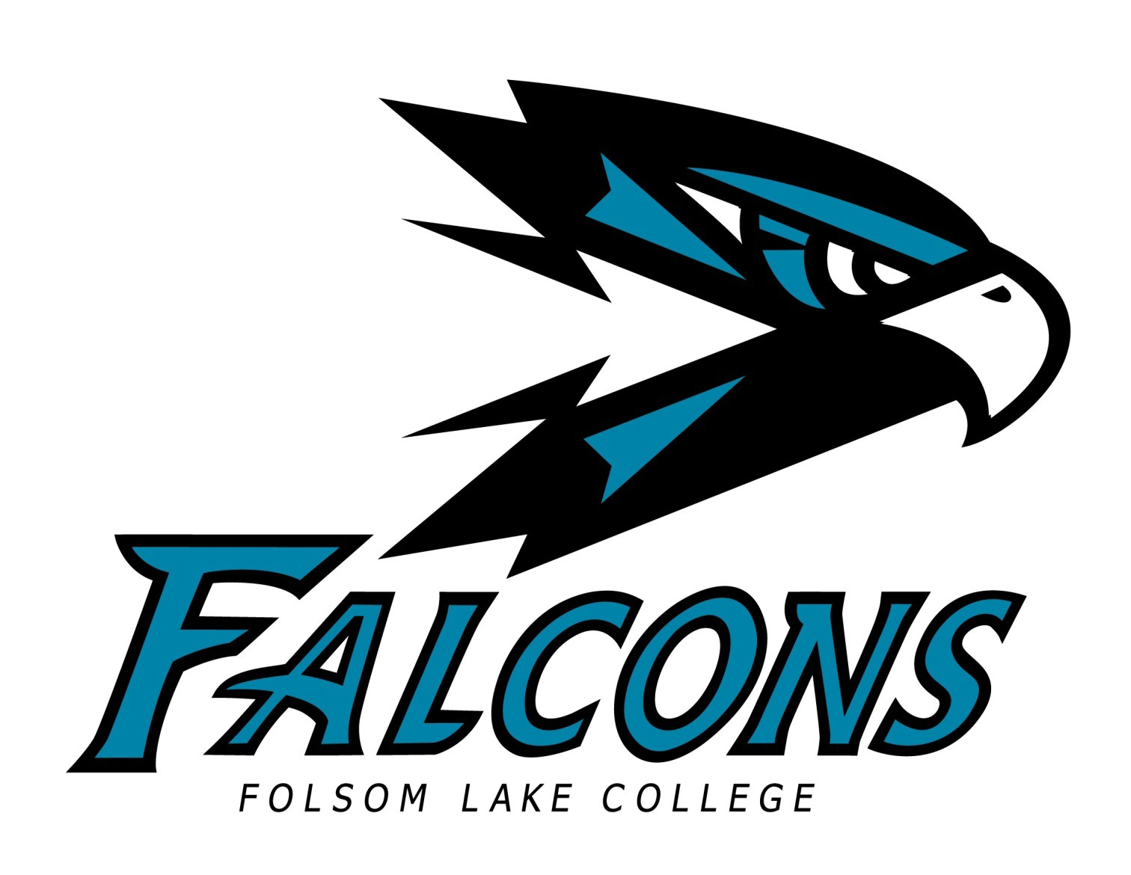

2015 – 2016
FLC STUDENT ATHLETE HANDBOOK

2014-15 FLC STUDENT ATHLETE HANDBOOK

CONTENTS

Introduction …………………………………………………… 1
Our Mission ………………………………………………….. 2
Athletic/Academic Philosophy…………………… 3
Falcons’ Athletic Staff ………………………….……. 4
Falcon Head Coaches………………………………….. 6
Academic Advising………………………………………. 7
Athletic Training …………………………………………. 9
Athletic Equipment & Apparel ………………... 11
FLC Code of Conduct ……………………………….. 12
Student Athlete Decorum ………………………….. 14
Travel Expectations ………………………………...….. 15
Fundraising and Uses ……………………………….. 15
Appendix A: Eligibility for Transfer………….. 16
Appendix B: Code of Conduct/Signatures

INTRODUCTION

On behalf of Folsom Lake College and particularly the intercollegiate athletics faculty and staff, thank you for choosing to be a part of the Falcon family. Our goal is for you to be successful in pursuing your academic and athletic goals. The successful student athlete is one who understands the importance of hard work, time management, and commitment. This handbook has been designed to orient Folsom Lake College student athletes to the college, its values, and the mission of our intercollegiate athletics program.

The information contained in this handbook should help answer questions you may have or help you find people who can answer your questions. There are policies, procedures, and rules that are unique to community college athletics, especially regarding your athletic eligibility, and it is important that you become familiar with those. It is also important that you familiarize yourself with the many resources you have available to help insure your success in the classroom.

Folsom Lake College is dedicated to your success. We are excited about watching you compete in the laboratory and playing field and we look forward to your future contributions as productive citizens in your local community.

Welcome to Falcon Athletics!

OUR MISSION

Folsom Lake College is committed to providing quality athletic programs that enrich and empower students to reach their full potential as informed and productive members of the community. FLC intercollegiate athletics will provide student athletes with opportunities that lead to their academic success and personal development, as well as foster self-fulfillment through athletics.
The individual rights and academic goals of the student athlete will not be compromised by the desire of the college to conduct successful athletic programs. Participation in the athletics program will augment the student’s formal education and will teach the life skills of cooperation, teamwork, perseverance and mutual respect. The athletics program is devoted to abiding by the rules and regulations set forth by the CCCAA, the Bay Valley & Big 8 Conferences, and Folsom Lake College’s vision and mission.

ATHLETIC/ACADEMIC PHILOSOPHY

The goal of Folsom Lake College Athletics is to maintain a balance between academic progress and athletic participation. Student athletes are expected to perform to their ability level in the classroom and in their sport.

Student athletes who continue to meet the Athletic and Academic Standards of the California Community College Athletic Association (CCCAA) and Folsom Lake College will be allowed to represent Folsom Lake College in intercollegiate athletic participation.

Furthermore, should conflicts arise between the academic requirements of the student athlete and the intercollegiate athletic program that cannot be resolved through the school policy or excused absences for athletic contest participation, the academic requirements will take precedent.

The college encourages student athletes to be proactive in their pursuit and attainment of their educational goal, adhere to student requirements and conduct regulations, be involved in Associated Students activities, and treat their athletic participation as a privilege, not a right. The college is committed to providing fair and equitable opportunities for both sexes and encourages student athletes to demonstrate culturally competent behaviors, attitudes, and traits; all of which are necessary skills in the 21st century global marketplace.
FOLSOM LAKE COLLEGE
INTERCOLLEGIATE ATHLETICS STAFF

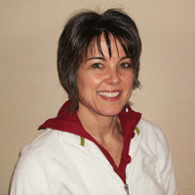
Kim Harrell Ron Richardson Dean of Kinesiology, Health, and Athletics Athletic Coordinator
G-181 608-6687 G-178 608-6812

Matt Wright Gayle Brown
Athletic Coordinator Athletic Eligibility Officer
G-176 608-6797 FL1-176 608-6644

Miriam Javier William Garcia
Athletic Counselor Athletic Trainer
FL1-168 608-6536 G-153 608-6551

William Pridemore Jeanne Plews
Athletic Equipment Attendant Administrative Assistant G-117 608-6802 G-180 608-6687

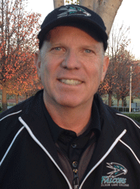
  - FALCONS’ HEAD COACHES

Patrick Rutz Craig Perez
Men’s Tennis Coach Women’s Tennis Coach

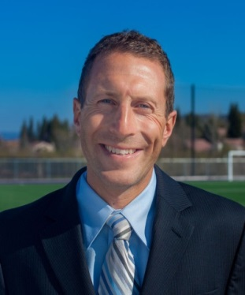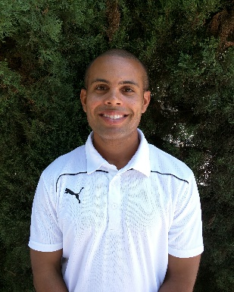

Barry Zarecky Donny Ribaudo Justin Johnson
Men’s Golf Coach Women’s Soccer Coach Men’s Soccer Coach

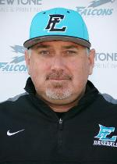

Amanda Ryan Rich Gregory

Women’s Softball Coach Men’s Baseball Coach

ACADEMIC ADVISING

Overview
Planning your academic program is not a task to take lightly. Each student athlete arrives with different levels of academic ability, preparation and motivation. Each major requires a different pattern of courses and each university has its own course numbering system and requirements. Don’t ever assume that you know the “road” to your academic plan. Always discuss developments and changes in your academic plan with the Athletic Counselor.

Student Education Plans (SEPs)
Prior to the beginning of athletic participation, the athlete must complete a Student Education Plan (SEP) (transcripts required) with an Athletic Counselor and review this plan at least once per semester. Fall sport athletes must have the SEP completed by October 15; spring sport athletes must complete it by March 1. Failure to complete SEP’s by the specified date will result in the athlete being declared ineligible for competition.

At the start of the third week of classes a hold is placed on all student athletes’ records that prevent the student from making any changes to their current registration. Athletic Counselor approval is required for all program changes. This approval process prevents student athletes from making mistakes that render them ineligible.

Grade Checks/Progress Reports
The Athletic Counselor will monitor student athlete academic progress and course attendance throughout the year with the use of Academic Progress Reports. The athlete will hand carry these reports and return them to the counselor by the specified date.
Progress Reports will be administered in week five (5) and week ten (10) of classes each semester. For short-term or odd-term classes, your coach will inform you when the progress report will occur. However, student athletes should be proactive and informally check grade status WEEKLY with the instructor for each enrolled class.

Student Athlete Study Center
All FLC student-athletes are required to attend a minimum of 2 hours weekly of Student Athlete Study Center (SASC). The SASC is located in PE-112. The SASC supervisor will verify hours of attendance and monitor student behavior in the SASC. Students must come prepared to study with appropriate materials, books, and class notes. Any student not actively working on coursework will be asked to leave.
After one semester of SASC attendance, student athletes with a minimum GPA of 3.0 may be exempted from SASC. Exempted students may be required to re-enter SASC if current grades or sub-standard performance in a class deem it necessary.

Eligibility
There are numerous rules and regulations regarding athletic eligibility set forth by the California Community College Athletic Association (CCCAA). The most pertinent for you to be familiar with are listed below:

- Student athletes are required to be enrolled in a minimum of 12 units (9 of which must be degree-applicable) to remain eligible during their season of sport. If at any time during the season the student drops below12 units, they are ruled ineligible to compete and remain ineligible until their unit load returns to at least 12 units. FLC student athletes may take courses at any of the Los Rios District colleges in order to meet the 12 unit minimum. The student athlete must also be enrolled in the appropriate Intercollegiate Sport class at FLC.

- Student athletes planning to participate in a second season of sport must complete and pass a minimum of 24 units (18 of which must be academic) between seasons of competition (including the semester of first competition). These units must be completed prior to the beginning of the semester of the second season of sport. Student athletes must also complete at least 6 units during their last full-time (12 or more unit load) semester prior to their second sport season.

- A student athlete who has competed in a college sport must maintain a minimum 2.0 GPA in order to be eligible for any subsequent sport season, computed since the start of the semester of the first competition.

- A student athlete who has competed in any sport at another California community college within the past two years must complete 12 units in residency at Folsom Lake College before they are eligible to compete in athletics. The student- athlete must provide the Athletic Counselor with official transcripts from their previous college.

Transfer/NCAA, NAIA Considerations
Student athletes planning to transfer to a 4-year institution should schedule regular meetings with the Athletic Counselor in order to monitor academic progress. NCAA rules are very specific regarding 2- year college transfers; many student athletes have missed an athletic scholarship opportunity because they did not complete enough units in their major at the 2-year college (See Appendix, Division I, II, III and NAIA).

ATHLETIC TRAINING/INJURY PREVENTION & TREATMENT

Requirements
Student athletes at FLC must participate in the requirements of the Athletic Training Program. The following forms must be completed and verified prior to participation:
• Physical exam/health history report
• Assumption of Risk
• Emergency cards
• Insurance information

The Folsom Lake College Athletic Trainer is responsible for certifying any athlete to be eligible to return to practice or competition following a reported injury (not the coach).

It is the athlete’s responsibility to allow adequate time for injury treatments and rehabilitation before practice or any game, meet, or match.

Training Room Location
FLC Gymnasium Building G-153.

Training Room Hours
A semester schedule will be provided to student athletes at the beginning of the sport season. Hours are also posted outside training office (G-155).

Physical Exams
All in-season athletes must pass an athletic physical screening prior to the sport start date. You will not be allowed on the court or field (even to practice) until you have passed your physical and have all paperwork on file in our office. Please refer to flcfalcons.com for the most up-to-date physical exam procedure. It is the athlete’s responsibility to have a physical examination prior to beginning practice and/or competition.

Insurance coverage
The college district’s athletic insurance (Special Insurance Services) is a secondary policy, which means if you are covered by personal health insurance, your policy must pay or deny a claim first. Any leftover balance can then be submitted to our insurance company for consideration. If you do not have any health insurance the district policy becomes primary. It has a $100 deductible, per injury. The district’s policy may not cover all the expenses and will not pay for deductibles or co-payments from your primary insurance. Our policy covers only in-season athletic injuries. YOU ARE RESPONSIBLE FOR ALL MEDICAL BILLS.

Reporting Injuries
Student athletes are required to notify training personnel of any injury, no matter how slight or severe. It is the athlete’s responsibility to report any athletic injury to the Athletic Trainer within 24 hours of the occurrence of the injury. Injuries must be immediately reported; don’t wait a week to see if your injury will go away. Injuries requiring a doctor’s visit must be documented at the time of injury or risk non-payment by the insurance carrier.

Athletic Training Room Rules
The Athletic Training Room is a medical facility and should be treated as one. The following rules will be strictly enforced:
- Athletes should clean up prior to entering the Athletic Training Room. If clothes are visibly dirty or sweaty, please change.
- Always rinse off prior to entering a whirlpool. Any turf, grass, dirt, sweat, or any other debris should be removed.
- Athletic Training Room phones and computers are off limits to athletes.
- No shoes on the treatment/taping tables.
- The Athletic Training Room is intended for the treatment and rehabilitation of athletic injuries. Please no loitering, napping, or lunging.
- Food is not permitted in the Athletic Training Room.
- To protect the privacy of other athletes, taking pictures or videos inside the Athletic Training Room is prohibited.
- No phone calls.
- Always sign in prior to entering the Athletic Training Room.

ATHLETIC EQUIPMENT AND APPAREL

The PE/Athletic Attendant provides various support services to the student athletes and coaches here at Folsom Lake College. These services include the issuing, maintenance, laundering, retrieval, and inventory of uniform and sport equipment items.

The Athletic Attendant will provide specific instructions for each sport team utilizing uniform laundry services, including time and location for uniform drop-off and uniform issuance.

All uniform and equipment items issued to the student athlete are the property of the Folsom Lake College Athletic Department. All issued items, unless otherwise stated, are to be returned to the equipment staff upon the completion of the season. Failure to return issued items (or failure to pay for lost items) will result in a “hold” being placed on the student athlete’s academic record and other applicable actions undertaken by the college to recover college assets.

FOLSOM LAKE COLLEGE

ATHLETIC CODE OF CONDUCT
All students representing Folsom Lake College in intercollegiate athletic competition are expected to:
- Accept the concept that participation in intercollegiate athletics is a privilege, not a right;

- Demonstrate good citizenship, sportsmanship, honesty, and integrity on the field or court, on campus, in the classroom, and in the community;

- Attend class regularly;

- Develop and follow an academic plan to obtain a certificate, an A.A. degree, or attain transfer status;

- Demonstrate and understand that participation in athletics is contingent upon adherence to all California Community College Athletic Association (CCCAA), Bay Valley & Big 8 Conference, and FLC athletic department rules and regulations;

- Acknowledge that compliance with the Student athlete Code of Conduct is required for participation in athletics at Folsom Lake College; and,

- Acknowledge that any violation of the Code of Conduct will result in appropriate progressive discipline as determined by the Head Coach, Athletic Coordinator, and/or the Dean of Athletics.

Sportsmanship
Folsom Lake College student athletes are ambassadors for FLC and enjoy certain privileges with such status. They also bear the responsibility of behaving with dignity and sportsmanship. Student athletes will conduct themselves with honesty and good sportsmanship during games and competition. Behavior must at all times reflect the high standards of honor and dignity that should characterize participation in competitive sports. Student athletes will act in a manner reflecting positively on the reputation of Folsom Lake College both on and off the field of play, when traveling, and participating at other institutions. Our core value is student athletes shall always maintain an attitude of respect toward opponents, officials, and fans. As models of good sportsmanship, student athletes should look for ways to encourage and appreciate quality play and effort, regardless of whether it is exhibited by a teammate, fan, or opponent.
While intense and emotional game action and conduct is certainly a reasonable part of intercollegiate sports contests, our student athletes should never demean the dignity and individuality of the opponent, the official, or of the athletic contest. Folsom Lake College student athletes are expressly prohibited from engaging in the following behavior at any intercollegiate athletic event:
- Fighting opponents, fans, or officials

- Verbal or physical taunting opponents or their fans

- Inappropriate celebrations with the intent to demean opponents or their fans

- Disrespectful attitude toward opponents, fans and game officials

- Profane and vulgar language and/or gestures

Substance Use
Folsom Lake College student athletes are expected to abide by the rules of the CCCAA and their respective FLC coach’s team rules regarding alcohol and substance use. While California state law allows alcohol purchase and consumption for adults 21 years of age and older, the FLC athletic department strongly discourages the use of alcohol by any team member during the season of sport. Under-age drinking is a violation of the law and the FLC Code of Conduct. Even those students who are of legal drinking age must abide by CCCAA and Student Athlete Code of Conduct (see page 19) rules relating to alcohol use.
The use of illegal and/or “performance enhancing” drugs is totally inconsistent with the purpose of intercollegiate athletics and creates a danger to the health and safety of student athletes and their teammates. Student athletes are specifically cautioned against illegal or unauthorized use of alcohol, drugs, and other intoxicants and shall not:
- Use or be under the influence of drugs not prescribed by a physician
- Drink, be under the influence of, or be in possession of alcohol on campus, during any intercollegiate event, athletic practice, on road trips associated with athletic events, or at team social activities
- Use tobacco products on campus during any intercollegiate event, athletic practice, on road trips associated with athletic events, or at team social activities.

The CCCAA Constitution prohibits the above-mentioned actions and the FLC athletics program will not tolerate the use of these products. Violations of this policy are subject to suspension or dismissal from the team at the discretion of the athlete’s coach or area Dean.

CCCAA Decorum Policy
This is the CCCAA code of behavior for all participants in sponsored athletic events.
Decorum violation is defined by the CCCAA as removal of a participant for verbal or physical misconduct, or unsportsmanlike conduct. For the purpose of this policy, the following definitions apply to FLC student athletes, staff, and sport coaches during any practice or game, meet, or match:
- PARTICIPANT—is a player, coach, team member, team attendant, official, or college
staff member.

- EVENT—is defined as the time a team or participant arrives at the event site until the
Team(s) and/or participant(s) depart the event site.

- EJECTION—Removal from a scrimmage/game/meet/match of a participant for the
remainder of the event.

  - Sport rulebook infraction: Removal from the event for actions not under the
jurisdiction of this policy, but are covered by the rules of the sport (foul out of a basketball game, 2 yellow cards in soccer, etc…)

  - Decorum Violation: Removal of a participant for verbal or physical misconduct, or unsportsmanlike conduct.

a. Verbal misconduct or unsportsmanlike conduct is defined as, but not limited to unsportsmanlike tactics, such as using profanity or vulgarity, taunting, spitting on an opponent, ridiculing, finger pointing, making obscene gestures, throwing gang signs, baiting an opponent, inciting undesirable crowd reactions, persistent arguing with officials, or aggressive behavior toward officials.

b. Physical misconduct is defined as, but not limited to any attempt by a participant to contact another participant in a combative manner unrelated to the sport. Such acts include striking or attempting to strike a participant whether or not there is contact.
All decorum violations will result in at least suspension from the next event. A second ejection from a contest in the same season will result in a suspension from all remaining contests.

Travel Expectations
When traveling as official representatives of FLC to athletic competitions, events, and appearances, and any other event affiliated with the Athletic Department or FLC, student athlete actions should reflect favorably on the College, their team, and themselves. Student athletes are expected to adhere to their particular team’s dress code, team rules, and curfew.

Uses of fundraised funds – What Student Athletes Need to Know
Each year, the college provides eligible, allowable funds to underwrite the majority of costs associated with intercollegiate athletics competition, including meals per diem, entry fees, transportation costs, uniforms, equipment/supplies, game, meet, or match apparel, travel and lodging, and other allowable expenses. However, additional funds are necessary to increase the quality of experience of participating student athletes. Thus, student athletes are encouraged to participate in fundraising events designed to benefit all FLC athletics programs.
To avoid any miscommunication or misinterpretation, the funds resulting from fundraising activities are utilized in the following ways: 1) to offset actual lodging costs when those costs exceed allowable lodging allocations; 2) snacks (e.g., water, sports drinks, protein bars, fruit) consumed by student athletes to/from athletic contests; 3) year-end student athlete recognition events; 4) student athlete awards; and, 5) additional apparel, supplies, and/or sports equipment beyond that provided by the institution. If any student athlete is unclear as to how the additional funds are used to support FLC athletics, each/all are encouraged to visit FLC’s athletic coordinator.

APPENDIX A

NCAA DIVISION I:

ELIGIBILITY REQUIREMENTS FOR 2-YEAR (2-4) COLLEGE TRANSFERS

NCAA DIVISION I TIME CLOCK:
If you transfer from a two-year college to a Division I school, you must complete all of your seasons of competition within five calendar years from your original date of full-time enrollment in any collegiate institution, including a two-year college. This “five-year clock” does not stop except under special circumstances (i.e., time spent in the armed services, an official church mission). This “five-year-rule” begins the first time you enroll in 12 units and attend the first day of class. If you are unsure of this rule, contact your coach or athletic advisor BEFORE enrolling as a full-time student.

If you are a Qualifier:
• Graduate from Folsom Lake College OR
• Need to attend Folsom Lake College as a full-time student for at least one semester (excluding summer terms).
• Average 12 transferable units of degree credit for each semester attended (excluding summer terms).
• Need a minimum GPA of 2.50 in transferable units (student enrolling FT on or after August 1, 2012).
- No more than 2 units of PE courses can be used to meet the transfer degree credit or GPA requirements

If you are a Non-Qualifier:
• Need to attend a Folsom Lake College as a full-time student for at least three semesters (excluding summer terms).
• Graduate from Folsom Lake College (25% of units must be completed at the two year school that awards the degree).
• Need a minimum of 48 transferable units of degree credit.
- The transferable units MUST include 6 semester units in English, 3 semester units of Math and 3 semester units of Science
• Need a minimum GPA of 2.50 in transferable units.
- No more than 2 units of PE courses can be used to meet the transfer degree credit or GPA requirements

**NOTE – Summer School Limitation!! Students entering a Division I college may not earn more than 18 semester units of transferable coursework during the summer and only 9 semester units of transferable degree credit may be earned during the summer immediately before transfer.

PROGRESS TOWARD DEGREE RULE
The 40-60-80% Rule for degree progress at an NCAA Division I school means that you need to be making progress towards your bachelor’s degree even if you are attending a two-year college. You need to meet the following percentage of degree requirements before you will become eligible.

After completing:
4/5 full-time semesters – 40%.........................Approximately 48 units toward Bachelor’s degree
6/7 full-time semesters – 60%.........................Approximately 72 units toward Bachelor’s degree
8/9 full-time semesters – 80%.........................Approximately 96 units toward Bachelor’s degree

REDSHIRT
Your five-year clock has started and is moving, but you do not participate in a given season. A student may use this option, for the year they sit out of completion, if he/she gets injured or runs into academic difficulty. See your coach or athletic counselor for more information.

NCAA DIVISION II:

ELIGIBILITY REQUIREMENTS FOR 2-YEAR (2-4) COLLEGE TRANSFERS

NCAA DIVISION II TIME CLOCK (10 Semester Rule)
This rule requires you to complete your 4 seasons of competition during your first 10 semesters of full-time enrollment. This allows you more flexibility in completing your seasons of competition.

To be eligible:
If you were a Qualifier out of high school, you need to:
• Complete a minimum of 12 units of transferable credit for each semester you started full-time at Folsom Lake College.
• Have a minimum GPA of 2.00 in transferable units.
• Spend at least one full-time semester in residence at Folsom Lake College (excluding summer terms).

If you were a Non-Qualifier out of high school, you need to:
• Complete a minimum of two full-time semesters in residence at Folsom Lake College. You must earn 25% of the units at the two-year school that awards your degree.

AND

• Graduate from the Folsom Lake College.

OR

• Complete a minimum of 12 units of transferable credit each full-time semester.
• Earn a minimum GPA of 2.00 in transferable units.

NCAA DIVISION III:

ELIGIBILITY REQUIREMENTS (2-4)

OPTION 1:
Students interested in these schools must have not previously participated in intercollegiate athletics

OR

OPTION 2:
You have participated in intercollegiate athletics and you would have been eligible academically if you had remained at Folsom Lake College in good academic standing.

**See your Athletic Counselor or the NCAA Guide for Two-Year College Transfers for more information.

4-2-4 Transfer Students

Four-year college students coming to Folsom Lake College, then transferring to a four-year

If you originally enrolled at a four-year college, transfer to a two-year college and then wish to transfer to Division I or II NCAA school, there is a separate set of rules you must meet in order to compete immediately at the Division I or II school. You must meet ALL of the conditions of one of the four options below before you transfer:

OPTION 1: (Div I)
• You must have completed 12 semester units of transferable degree credit for each semester of full-time attendance with a minimum GPA of 2.00.
• One calendar year must have lapsed since your transfer from the four-year college.
• You must have graduated from Folsom Lake College. (If you attend more than one two-year College, at least 25% of your degree requirements must be earned at the two-year college that awards the degree).

OR

OPTION 2:
• You return to the NCAA school from which you transferred to the two-year college, provided that you did not have an unfulfilled residence requirement at the time you left the NCAA School; and you passed 24 transferable units and a 2.00 GPA.

OR

OPTION 3:
• The original college you attended did not sponsor the sport in which you compete (and you did not attend any other college that did sponsor the sport).
• You were a Qualifier based on your high school record.
• You completed 24 semester units of transferable credit with a minimum GPA of 2.00 in your transferable units.
• You completed 12 semester units of transferable credit for each term you were a full-time student at Folsom Lake College.
• You spent at least two semesters as a full-time student at Folsom Lake College.

OR

OPTION 4: (Division II)
If you are transferring to a Division II college and, for a consecutive two-year period immediately before you begin practice or competition, you have not practiced or competed in intercollegiate competition or in an organized non-collegiate competition while enrolled as a full-time student at a college. This two-year period would not include any time before your first full-time enrollment at any two- or four-year college.

Please note: There is a difference between academic and athletic requirements

NAIA Rules Snapshot

An NAIA student-athlete: 2012
2-4 Transfers

- As a transfer student-athlete from Folsom Lake College, you must earn 24* units during the last two full-time semesters prior to transferring to compete,

and

- Earn a 2.00 GPA in all previous college course work

- For purposes of athletic eligibility, units earned with grades of ‘A’, ‘B’, ‘C’ or ‘D’ are counted only once in regards to the 24-unit requirement
  - Student-athletes and repeat courses
    - Example #1; If a student received an ‘A’, ‘B’ or ‘C’ in a class and repeat it, they cannot count the units for the repeated course towards the 24 units even if they are allowed to repeat the course
    - Example #2; If a student received a ‘D’ in a class and repeats it, they cannot count the units for the repeated course towards the 24 units even if they earn a higher grade
    - Example #3; If a student received an ‘F’ in a class and repeats it, they can count the units for the repeated course towards the 24 units if they earn a higher grade
    - Example #4; If a student received a ‘W’ in a class and repeats it, they can count the units for the repeated course towards the 24 units if they earn a grade of an ‘A’, ‘B’, ‘C’ or ‘D’

- Units earned in summer school can be used to meet the 24-unit rule if;
      - They are taken between the last two full-time semesters, or
      - They are taken after the last two full-time semesters
      - They have not previously earned a letter grade of ‘A’, ‘B’, ‘C’ or ‘D’

- In order to play the 3rd season of the same sport, the student-athlete must have 48 semester units completed (all units from transcript can be used, including repeated course work)

- You must be within your first 10 full-time semesters of attendance as a regularly enrolled student

- Once into junior and senior year, students have to maintain a 2.00 GPA.

*Complete no more than 12 of the 24 units during summer or intersession

